**15-03-2021**

RMSI Pvt. Ltd.

Project Management Plan

Hot Project

# **Project Management Plan**

The Project Management Plans follow the below steps to develop a plan that results in quality deliverables on time and within budget.

### **1. Collection of requirements from key stakeholders.**

First step in defining Project management planning process is collection of exact requirements from respective stakeholders/clients. Once you have this information, you will be able to define the scope of the project and determine exactly what you need to deliver to your stakeholders. It is essential to gather necessary inputs which could directly detrimental to project’s execution and success.

RMSI will collect all the necessary inputs, software licences requirements (if the project is onsite) and take essential support to start the project in project kick-off meeting.

### **2. Defining the scope of the project.**

Second and important process in project management plan is to identify and position clear understanding of the boundaries of the project. RMSI will use 3W & 1 H approach in defining scope of project in discussion with stockholder and Product owner & asking some question as:

1. What problems are the stakeholders trying to solve?
2. Who will be the beneficiary and what needs to deliver?
3. Why (importance/needs) to develop this product, what functionality it should contain, and *what is it intended to do*?
4. How will development team are supposed to implement product?

RMSI will encourage to put some points in kick of meeting with respective stakeholder which will initiate to develop a comprehensive description of entire project scope statement.

### **3. Create a work breakdown structure.**

Work breakdown structure enables two most important element of project management as planning and coordination. This process structure will allow RMSI to assign respective resource person to various phases of project execution based on skills requirement.

RMSI is intended to follow agile scrum methodology in full implementation of this project. The work break down structure according to project requirement will require following key personals:

Scrum Master

Product Owner

**Development Team**

.Net Developer

DB Developer

Test Engineer

### **Define project activities.**

Project activities gives detail information about accomplishments that must be performed to create the deliverables of the project. According to project requirement, the entire work has been distinguished with three sprints of total eight weeks plan (project delivery would be on last day of 7th week) with sprint 0 is allocated for requirement gathering phase.

The sprintwise assigned project activities for this project is illustrated in below table:

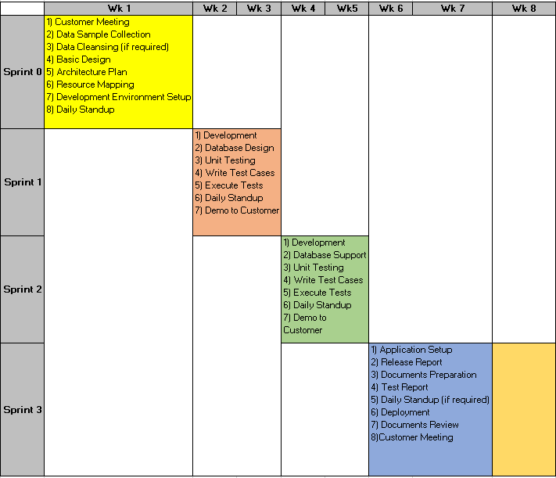

### **Estimation of activity duration, and resources.**

Proper estimation is vital part for project management, since it help in determining credibility of plan, setting expectations of product delivery, allocating no. of resource person and keeping cost factor under control. The estimation is entirely dependent on scope of project.

**Activity duration/ Sprintwise timeline:**

The entire project has been divided into 8 weeks of working span i.e. total 33 days of working days and 1.5 month duration. Sprintwise timeline of project plan in illustrated below: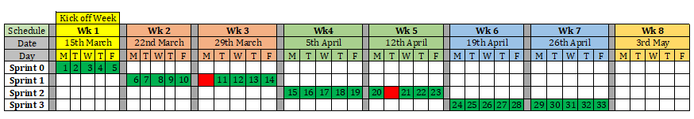

### **7. Assigning resources to work packages and activities.**

Material, software, infrastructure, technology experts, etc. are essential part in project execution. RMSI will require skills level needed for executing project actives which is given below:

***Software Requirement:***

The software requirements and related capabilities of each software and quantities of professional licences requirement is given in following table:

|  |  |  |  |
| --- | --- | --- | --- |
| Sr. No. | Product name | Product capabilities | License Quantity |
| 1 | Visual Studio 2019 | . Net Programming | 1 |
| 2 | SQLite DB | Storage of data into database and migrating to Postgres db. | Open Source |
| 3 | Postgres DB | Publishing data to WebGIS Server and making db supported application | Open Source |

***Technology Expert Requirement:***

Below are the proposed roles of development team within the project. The proposed team will be working by following cross functional approach.

|  |  |  |
| --- | --- | --- |
| ***Role*** | ***Proposed Personnel Experience*** | ***Proposed Personnel Domain/Technology Experience*** |
| Product Owner | ~5 to 10 years of experience | Project Management , communication with stakeholder |
| Scrum Master | ~5 years of Industry experience | Team leading, Project Management , Project Design |
| .Net Developer | ~5 years of Industry experience | Coding and development of product |
| Test Engineer | ~5 years of Industry experience | Testing and creating unit cases. |
| Database Engineer | ~5 years of Industry experience | Database maintaining, creating, storage, export, etc. |

### **8 Development of all subsidiary plans.**

Other most important part in Project management planning which involves in developing comprehensive & realistic plan for this project, and minimise fuzziness between development team & respective clients/stakeholders are illustrated in chart below:

Change Management Plan

Procurement Management Plan

Project Scope Management Plan

Project Management Plan

Schedule Management Plan

Quality Management Plan

Staffing Management Plan

#### **8.1 Change Management Plan:**

The change management Plan is used to describe your change control process in project execution. It is an efficient way of providing oversight, ensuring adequate feedback and reviewing of the necessitate changes in planning process. Changes to any project must be carefully considered and the impact of the change must be clear in order to make any type of approval decisions.

RMSI is liable to provide change management plan where the clients as well as development team discovers scope of improvement or some changes in project with respective authorities’ approval and it will be tracked & monitored throughout sprint delivery. Steps involved in Change Management Plan are listed below:

Step 1: Identify the need for a change (Any Stakeholder)  
Requestor will submit a completed TSI change request form to the project manager

Step 2: Log change in the change request register (Project Manager)  
The project manager will maintain a log of all change requests for the duration of the project

Step 3: Conduct an evaluation of the change (Project Manager, Project Team, Requestor)  
The project manager will conduct an evaluation of the impact of the change to cost, risk, schedule, and scope

Step 4: Submit change request to Change Control Board (CCB) (Project Manager)  
The project manager will submit the change request and analysis to the CCB for review

Step 5: Change Control Board decision (CCB)  
The CCB will discuss the proposed change and decide whether or not it will be approved based on all submitted information

Step 6: Implement change (Project Manager)  
If a change is approved by the CCB, the project manager will update and re-baseline project documentation as necessary as well as ensure any changes are communicated to the team and stakeholders

#### **8.2 Procurement Management Plan:**

RMSI has given respective project deliverables & costing plan with clear identification of project execution, necessary steps of sprint activities and responsibilities from beginning to the end of project. Company will ensure facilitating successful completion of entire project and giving proper defined DoD i.e. definition of done. The project manager has worked with the project team, contracts/purchasing department, and other key players to manage the procurement activities for particular costing of project.

#### **8.3 Project Scope Management Plan:**

The entire project scope must be clearly defined and documented in order to manage project plan efficiently. There might be an adverse effects (such as cost overruns, unnecessary workload, delay in response & deliverables, or other unintended consequences) in occurrence of failure to establishment and communication of project scope.

Therefore, owing to all this significances; RMSI is providing project scope management plan/ report addressing following terms:

1. Who has authority and responsibility for scope management.(Stakeholder, Product Owner, etc.)
2. How the scope is defined (i.e. Scope Statement, Statement of Work, etc.)
3. How the scope is measured and verified (i.e. Quality Checklists, Scope Baseline, Work Performance Measurements, etc.)
4. The scope change process (who initiates, who authorizes, etc.)
5. Who is responsible for accepting the final project deliverable and approves acceptance of project scope.

#### **8.4 Schedule Management Plan**

The schedule management plan gives general framework and development of entire project schedule which gives throughout understanding of project and ensuring completion on time using appropriate allocated resource & measurement of improved performance.

RMSI is intended to provide scheduling of Project plan with following key necessitates:

1. Discussion of the scheduling tool/format,
2. Schedule no. of milestones to be achieved
3. Schedule development roles and responsibilities.

Schedule Management plan will also allocate additional scope of project to be achieved or project addition to be managed in subsequent stages of work. Schedule management plan contain sprintwise meeting of project plans with following timeslots:

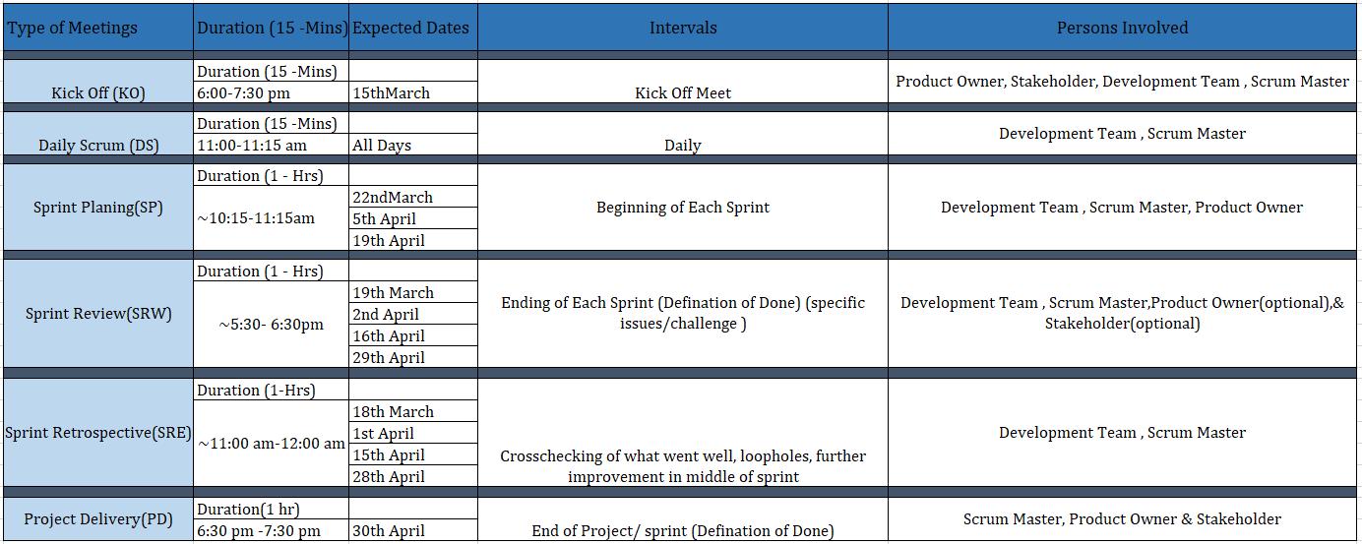The project stakeholders, product manager will participate in kick off, review meeting, and Project delivery meeting of proposed schedule plan and assist in its validation.

Sprint and week-wise deliverables of schedule management plan is illustrated below: 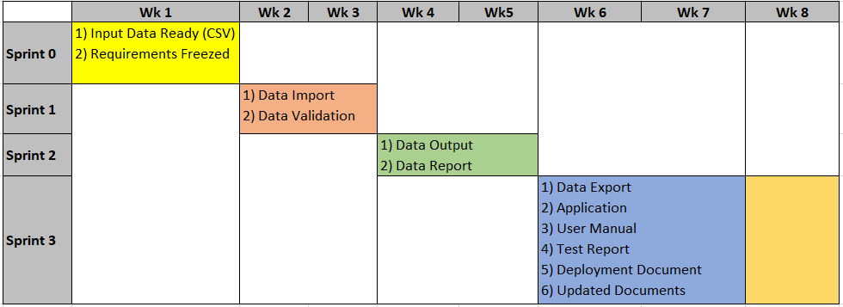

#### **8.5 Quality Management Plan**

The quality management plan will be used to conform the respective deliverables for project would establish acceptance standard. Planned work and task should be defined to measure defined understanding with quality i.e. error free working project delivery with an acceptable standards/ manner. This plan should include quality roles and responsibilities, quality control, quality assurance, and quality monitoring.

#### **8.6 Staffing Management Plan**

This plan would deliver exact information of capabilities and responsibilities of allocated staff of project. Staffing management plan gives matrixed or projected organizational structure depending on which is being used for this project. Staffing management project plan should also include how resources will be procured and managed as well as the key resources needed for the project.

**Project Manager** (1/2 position)(Product Owner & Scrum Master): Project Manager is responsible for planning, creating, and/or managing all work activities, variances, tracking, reporting, communication, performance evaluations, staffing, and internal coordination with functional managers.

**.Net Developer / Programmer** (1 position): .Net Developer is responsible for coding and programming for the HOT Project. All coding and programming tasks will be reviewed by the Programmer prior to implementation. Responsibilities also include assisting with risk identification, determining impacts of change requests, and status reporting. The Programmer will be managed by the Project Manager and feedback will be provided to the functional manager for performance evaluations by the Project Manager and Senior Programmer.

**Testing Engineer** (1 position): Testing Engineer is responsible for helping establish testing specifications for the HOT Project with the assistance of the Project Manager and Programmer. The Testing Specialist will be managed by the Project Manager who will also provide feedback to the functional manager for performance evaluations.

**Database Developer** (1 position): Database developer is responsible for storage and maintaining database for the HOT Project and work with guidance of Project Manager and Programmer.